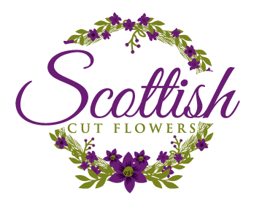
The simple act of adding flowers can transform a room into a celebration of colour and scent.
Our DIY buckets are available to anyone for any occasion.
This option is particularly popular with wedding couples looking to arrange flowers themselves, both to add a personal touch and to help keep control of their budget.
Each flower bucket is filled with a beautiful selection of focal & filler flowers in your specified colour scheme. One bucket holds 60-80 stems which is enough to create up to 6 jam jar posies, or 2 medium sized table centres, or 2 bouquets.
Of course, this varies from person to person depending on how full you wish the arrangements to look.
A bucket of mixed seasonal flowers costs £70.
A bucket of extra greenery costs £40, this can be handy to help fill-out arrangements or simply if you like a lot of foliage.
If you would like to have a practice arranging flowers and get some floristry tips in the process, we offer floral workshops on a bespoke basis for you to build confidence.
To order your DIY buckets just complete the form below, save a copy to your computer using your name and the date they are required (for example Rosie 21.8.21) and send back a copy to contact@scottishcutflowers.co.uk
If you are not 100% certain about the number of buckets you require that’s O.K, the order can be finalised as soon as you’re sure, or at the latest 1 month before your collection date.
We do however advise customers to put in a best-guess order now, so you have the opportunity to save the date with us. The reason for this is that we only take a limited number of orders per week to match supply and demand, therefore we operate on a first come first serve principle.

While we prefer customers to collect their order, delivery is available at an additional fee of 45p per mile (round trip) and £10 per hour to cover wages. The hourly fee will be rounded up to the nearest half hour. Delivery must be stipulated when you submit the order form for confirmation.
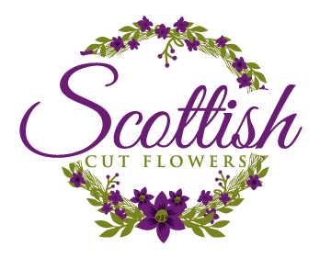
DIY Bucket Order Form

Date the flowers will be collected Click or tap here to enter text.
Venue Name Click or tap here to enter text.

If delivery is required please supply postcode Click or tap here to enter text.
Date and time the flowers need to be delivered Click or tap here to enter text.

Contact details
Name Click here to enter text.
Phone Number Click here to enter text.
Email Click here to enter text.

Preferences
Main Colour(s) Click here to enter text.
Colour(s) to avoid Click here to enter text.
Flower(s) to avoid Click here to enter text.
Do you have a theme? (wild flower for example) Click here to enter text.
Additional comments: Click or tap here to enter text.

Order Form
Input quantity required in the Number Required column below for each item then hit the CTRL and A buttons and once all the text is selected click the F9 button to see totals.
Buckets | Number Required | Price per Item | Total
Flower Bucket |  | £70 | £0.00
Foliage Bucket |  | £40 | £0.00
Total |  |  | £0.00

Next Steps
Save a copy of this form with your full name and the date you require the flowers for. Then email the form to contact@scottishcutflowers.co.uk
We will review your order and confirm if the date is available, you will then receive an invoice for a non-refundable booking fee to secure your order. The booking fee will be deducted from the final balance which is due a month before the collection/delivery date.

If you have any questions please check our FAQs page: https://www.scottishcutflowers.co.uk/faqs
If your question hasn’t already been answered then please don’t hesitate to contact us directly.

